Proxy
(Structural)

According to GoF definition of proxy design pattern, a proxy object provide a surrogate or placeholder for another object to control access to it. A proxy is basically a substitute for an intended object which we create due to many reasons e.g. security reasons or cost associated with creating fully initialized original object.
When to use proxy design pattern
A proxy object hides the original object and control access to it. We can use proxy when we may want to use a class that can perform as an interface to something else.
A proxy can be used to add an additional security layer around the original object as well.

Real world example of proxy pattern
- In hibernate, we write the code to fetch entities from the database. Hibernate returns an object which a proxy (by dynamically constructed by Hibernate by extending the domain class) to the underlying entity class. The client code is able to read the data whatever it needs to read with the proxy.
These proxy entity classes help in implementing lazy loading scenarios where associated entities are fetched only when they are requested explicitly. It helps in improving performance of DAO operations.
- In corporate networks, internet access is guarded behind a network proxy. All network requests goes through proxy which first check the requests for allowed websites and posted data to network. If request looks suspicious, proxy block the request – else request pass through.
- In aspect oriented programming (AOP), an object created by the AOP framework in order to implement the aspect contracts (advise method executions and so on). For example, in the Spring AOP, an AOP proxy will be a JDK dynamic proxy or a CGLIB proxy.

Architecture
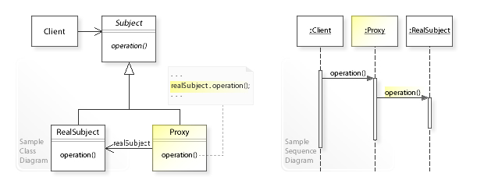

Step 1
public interface RealObject {
public void doSomething();
}

Step 2
public class RealObjectImpl implements RealObject {

@Override
public void doSomething() {
System.out.println("Performing work in real object");
}

}

Step 3
public class RealObjectProxy extends RealObjectImpl {
@Override
public void doSomething()
{
//Perform additional logic and security
//Even we can block the operation execution
System.out.println("Delegating work on real object");
super.doSomething();
}
}

Step 4 (Client)
public class Client {
public static void main(String[] args)
{
RealObject proxy = new RealObjectProxy();
proxy.doSomething();
}
}

Output:
Delegating work on real object
Performing work in real object

Resources:
https://howtodoinjava.com/design-patterns/structural/proxy-design-pattern/

